***Date:*** 5/6/2021

***Name***: Manar Mohamed Foad

***BN***: 952

***TOPIC***: Artificial intelligence

### **Application Brief**:

AI is one of the hottest buzzwords right now. People love AI. People hate AI. And, while almost every media outlet is talking about AI, most people do not even know what it is and what exactly it can do. AI is a mystery technology. Some of the messages in the media warn that it could take all of our jobs, replacing humans completely in the workforce. Others present AI as a panacea for the world’s biggest problems. While both messages grab your attention, unsurprisingly, neither is entirely true.

If you start now by taking a step back and thinking about how you can expand your expertise to complement AI, you will thrive in the AI-driven world. Building a creative skillset will set you apart as you enter a society driven by human-machine collaboration. The new way of work will help you reach your untapped potential. So, why not get started now and jump on the bandwagon. You can either lead the way or fall behind while others embrace the change.

# **Screenshots:**

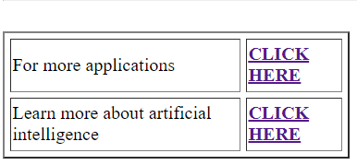

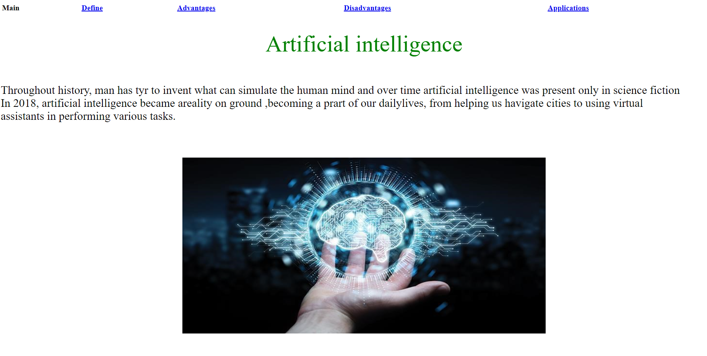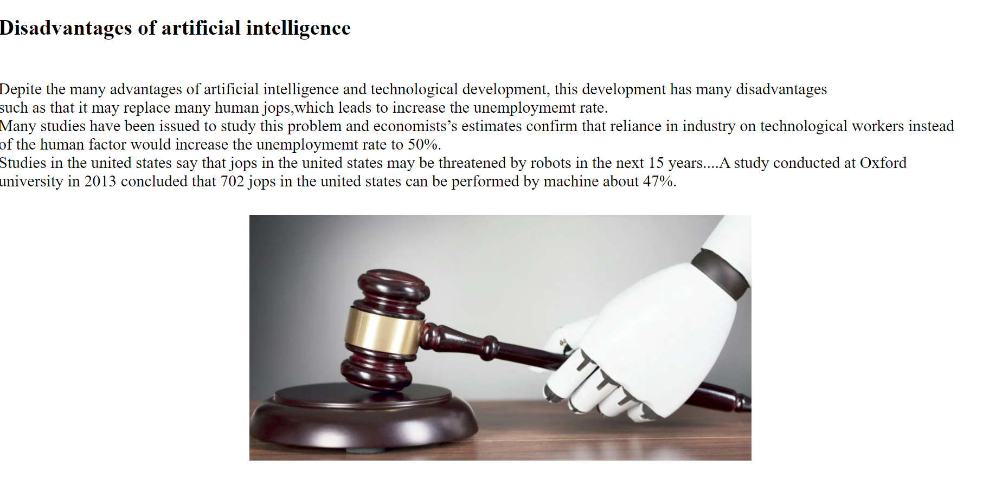

# 

# **Sure code:**

